Final Project Proposal

MAD SU2021

**Course Registration App**

**Kate Becvar**

**Nick Ciaccio**

Overview

Our team was tasked to design a mobile application using the Android Studio software combined with the application of the material we covered throughout the course. This idea turned into what will be the course registration app. This application will provide new or present students a way to search, register, and drop classes as needed throughout their academic career at Lewis University from their phone or other mobile devices.

Our primary goal is to create an app that goes through class registration.  The application will have a login page and an account registration page should this be the user’s first time using the app. Each page will have a logout and back to the main page button for easier navigation. Once a user has signed in or created an account, the app will have a search activity that provides the user the option to search, add, and drop classes based on the entry of their desired degree type. When the user selects “Search” they will enter their desired degree and classes based on that entry will be returned to the user to select. Note that add/drop classes are not the same as registering or dropping a class, it is a list that will keep track of the classes the user is thinking about taking the following term. Once that activity is complete, they will see those classes available for registration in the register activity. The user will then be able to select the classes using radio buttons and register for classes. Once registered, their drop function will be available and like the register tab, it will allow the user to drop one or all classes based on radio group selection. The last menu option is to view their newly created schedule once registration has been complete to double check for any mistakes and to have an overview of their classes.

Layout

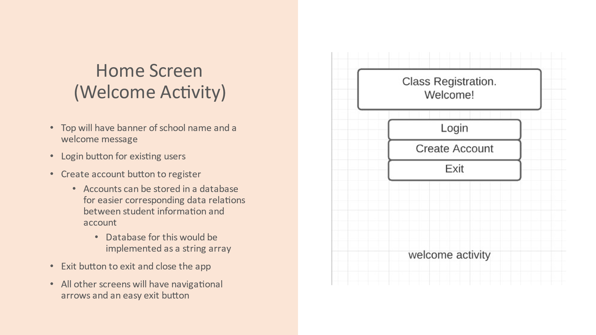

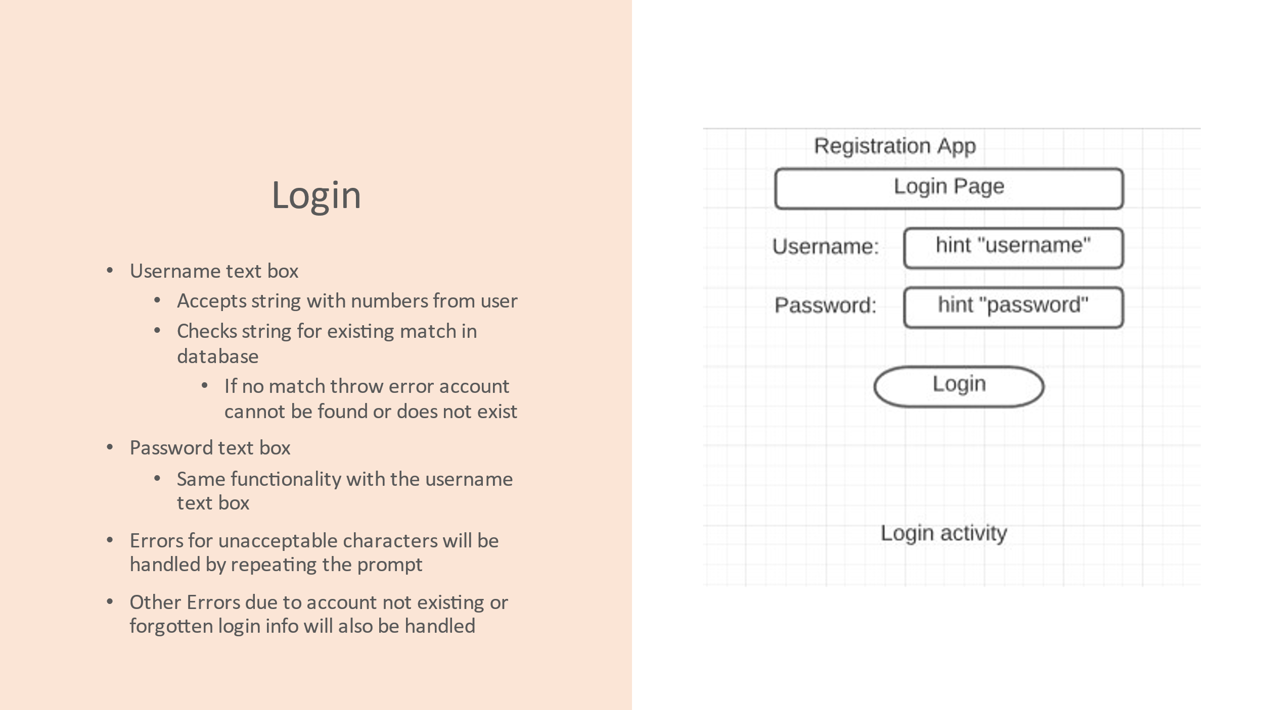

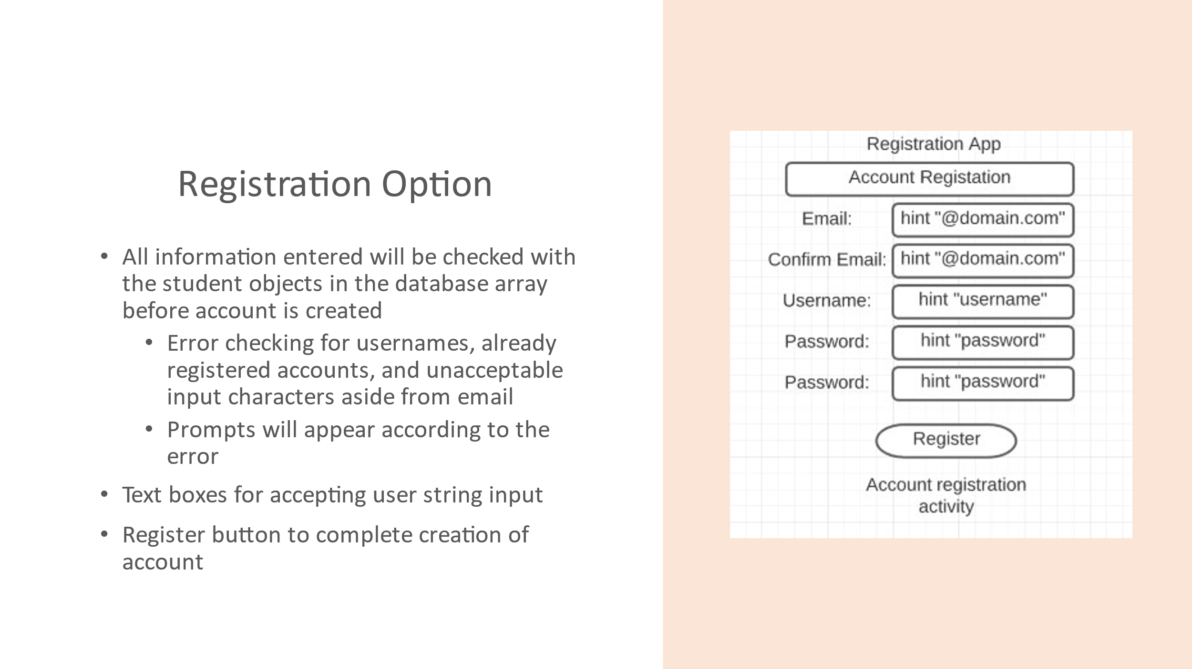

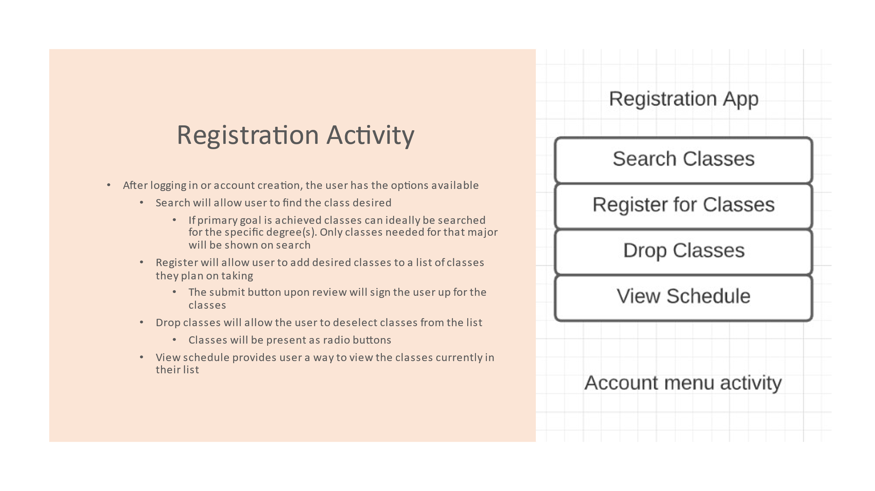

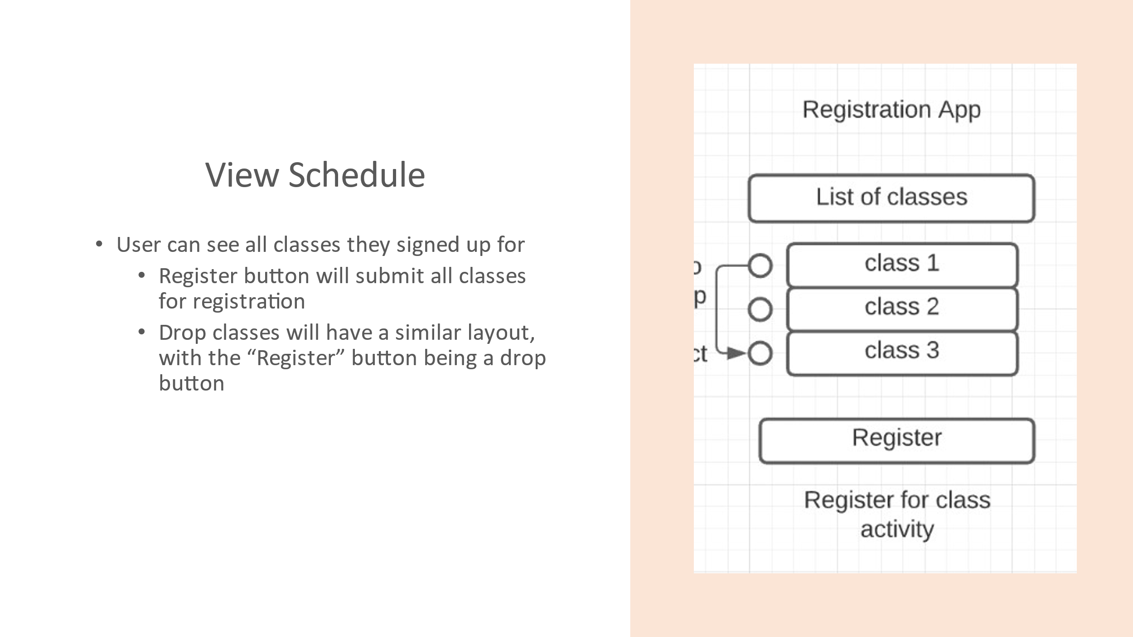

Market Analysis

We could not find any apps that would allow students to specifically sign up and register for university classes. All the apps found where more focused around signing in for attendance (i.e using an i-clicker), or focused on helping a user schedule out their day with appointments, meetings, breaks, and other activities similarly.

Given the limited knowledge and experience of the team, the primary design was created with simplicity in mind. If the simpler design can be created and implemented well, the additional goal is to make the app stand out. This means the app should be more efficient and easier to use than going through the mylewis website. The app would stand out by providing the counselors (corresponding to the students major and name) contact information on the search/add/drop classes page, and by color coding classes taken, needed, and already completed. The course registration app would provide a more appealing and easier to use interface for easier class selection and registration than going through blackboard.